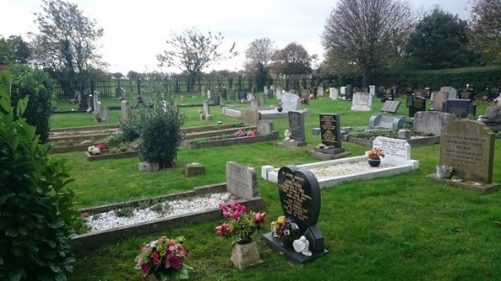
KSPC CEMETERY POLICY

Responsibility and Liability
- Responsibility for the burial ground located at Water Lane, Kirk Smeaton, lies with Kirk Smeaton Parish Council (KSPC).
- KSPC has legislative responsibility for overall safety within the burial ground.
- In order to comply with legislative requirements, KSPC will carry out both formal and informal inspections to ensure the burial ground is a safe place for visitors and all others who may visit or work in the burial ground.
- Whilst KSPC has overall responsibility for the safety of the burial ground, including risks from unstable memorials, it does not own any of the memorials. The owner of the memorial is the grave owner.
- The owner of a memorial is responsible for maintaining their memorial in a good condition.
- Memorial Stonemasons must ensure memorials are erected safely and in accordance with laid down standards and codes of working practice and hold a current registration with BRAMM and comply with BS8415.
Memorials assessed as presenting an immediate Danger
- In cases of immediate danger, KSPC will take urgent action to make safe dangerous memorials.
- KSPC will only take direct action to remove unstable memorials in circumstances where grave owners cannot be traced and where memorials cannot be made safe by being laid down. (see point 3 on page 3 of this policy)

Memorial Safety Inspections
- Memorial Safety is based on a risk assessment approach and as a priority, this will involve identifying any memorial that presents an immediate danger, or is likely to present an imminent danger.
- KSPC’s Grounds Maintenance Contractor will carry out an informal inspection of all memorials when undertaking grass cutting around the memorials. Any issues will be immediately reported by the Contractor to the Clerk of the Council, or in the Clerk’s absence, to the Chair of the Council.
- The Clerk of the Council, accompanied by the Grounds Maintenance Contractor (or a Parish Councillor), will carry out a detailed and thorough inspection of all memorials on a 6-monthly basis taking place in January and July of each year.
- A record of the Clerk’s memorial inspections and the results of the inspections will be kept by KSPC and will be available to view on request by writing to the Clerk of the Council.
Procedure
- Inspect and as a matter of urgency make safe any memorials that present an immediate danger.
- Any memorial considered to be dangerous will be laid down to eliminate the danger.
- The inspection will identify any signs of decay e.g., loose or cracked cement and the degree of any lean that might be apparent. The inspection will also look for signs of soil erosion around the base of a memorial.
- Once an unsafe memorial has been identified, information concerning the memorial will be recorded on the memorial inspection form (Appendix 1) and on the log sheet (Appendix 2)
- All relevant details, including the identity of the memorial, the condition of the memorial and the work required to reinstate the memorial will be recorded on the log sheet.
Dealing with unstable memorials
- Where the inspection shows evidence of movement but the memorial is not in imminent danger of collapse, the condition of the memorial will be noted and a notice placed on the memorial. The owner will be notified in writing of what remedial action is necessary to ensure the memorial stays safe.

- Where no owner can be found, the condition of the memorial will be monitored and if its condition deteriorates, KSPC will lay down the memorial and find out what work is required to return the memorial to an acceptable condition and the cost.
- KSPC would like to ensure that its burial ground continues to provide an attractive place of interment. In circumstances where a grave owner cannot be found, KSPC may decide to fund the cost of minor repairs or reinstatement work. This will be decided at a meeting of the Parish Council.
- Where a memorial assessed as presenting an immediate danger has been laid down, KSPC will write to the grave owner informing them of the action that has been taken. The letter will inform the grave owner to appoint a registered Memorial Stonemason should they wish to re-erect the memorial. The cost for this work will fall entirely on the grave owner.
- Memorials will be left laid down in circumstances where no repair or reinstatement work is carried out.

